String Classes

1.String
- A string can be defined as sequence of characters or numbers or special characters within the pair of double quotes is called as String.
- There are four string classes defined by java
  - String
  - String Buffer
  - String Builder
  - String Tokenizer
String Classes
All string classes are called as predefined classes or user defined classes.
String class is part of package called java.lang.
To create string-based objects there are two objects
- Without new keyword
- With new keyword
Without new keyword
Whenever we create String-based objects without new keyword those objects will get created within the heap memory inside the string constant pool before creating any object within the string constant pool it will check if a object is present or not.
If the object is not present within the string constant pool only then an object gets created within the string constant. But the string object is already present within the string constant pool then java will not create a new object and it will redirect the reference to the existing objects.
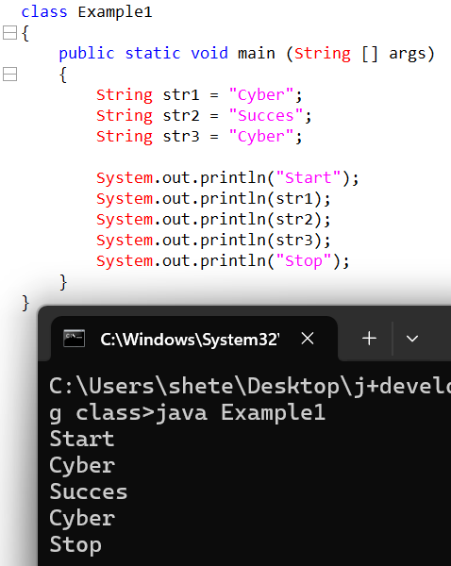

With new keyword
Whenever we create string-based objects with new keyword these objects will be created as part of heap memory and regardless whether the string is duplicate or not, separate objects will get created in the heap.

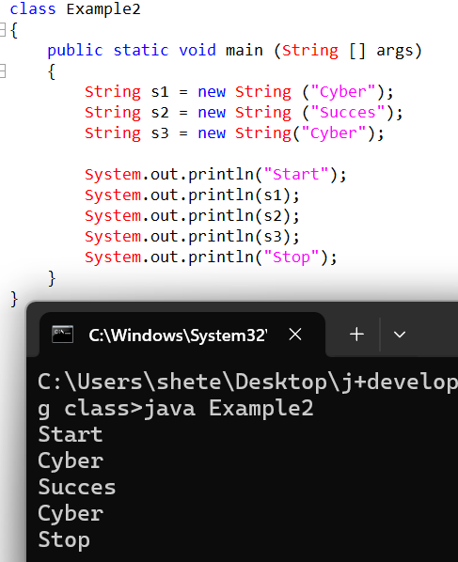

To compare the strings we use ‘==’ operator
The == operator will perform what comparison
- Reference comparison
- Content comparison
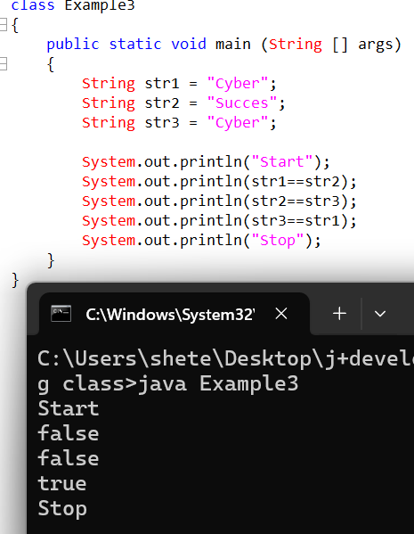

- The == operator will always perform reference comparison.
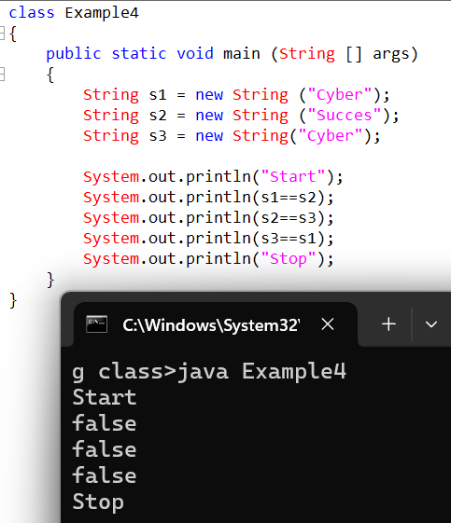

Whenever we print a normal class reference variable it will print the address but whenever we print string class reference variable it doesn’t print the address but it prints the value, Why?
- Whenever we print the reference variable of normal class it will internally call the toString() of the object class, the toString () of the object class will always be responsible to print the address.
- But within the string class the toString() method is overridden hence rather than returning the address it returns the value.
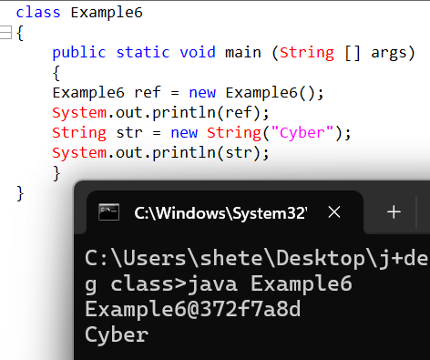

Can we override the toString() method of object class >>
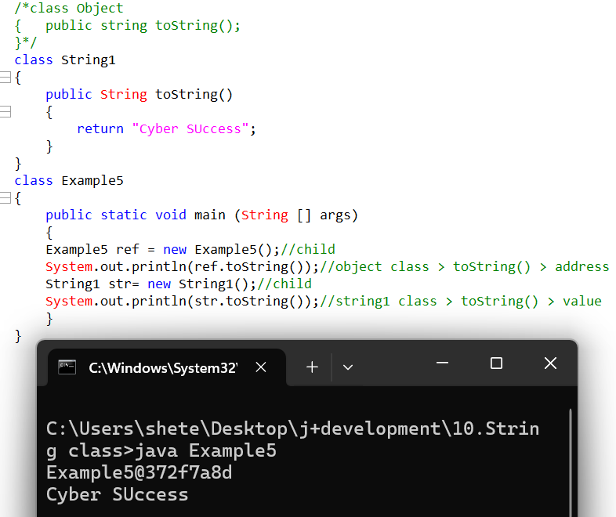

toString()
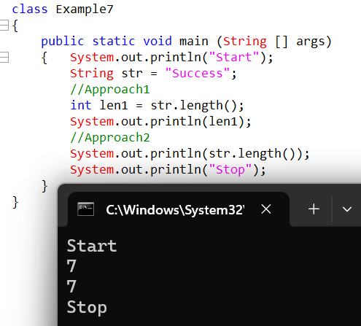

Write a java program to check if the length of the username is more than 8 characters, if it is more than eight then display login successful else login unsuccessful.
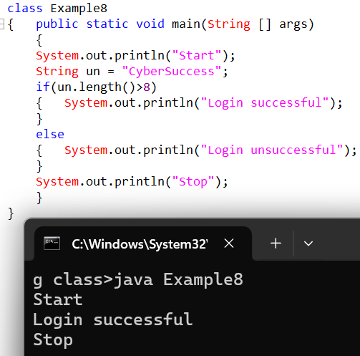

- String classes by nature called as immutable classes
- Immutable means its object data cannot go and change such a behaviour is called as immutable behaviour.
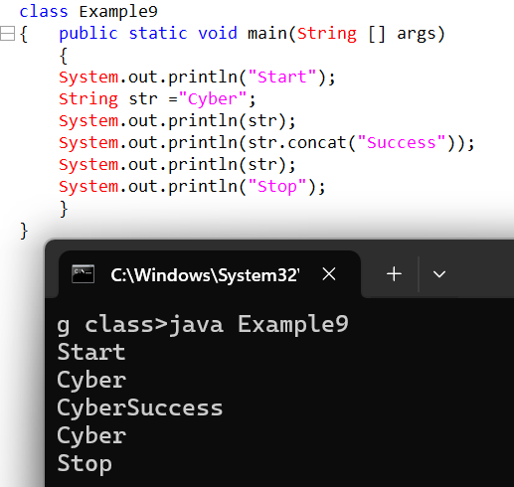

Stack
Cyber
Cyber Success

Whenever we try to store concatenated object within the string it will not change its original object value but we create a new object and will point to new object such a behaviour is called as immutable behaviour.
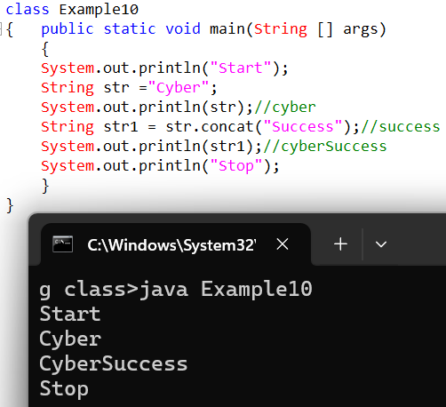

StringBuffer class
StrinBuffer is also part of java.lang package.
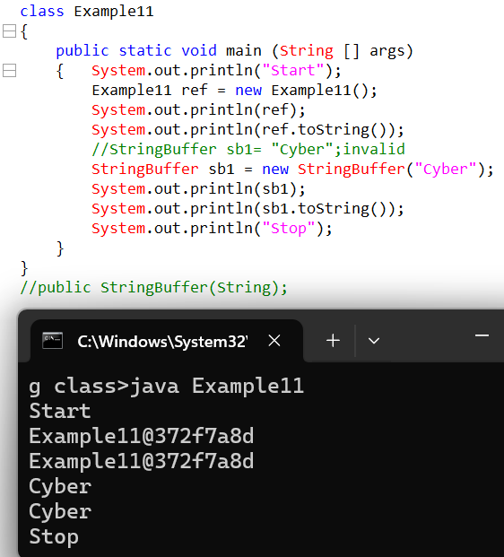

String Buffer class is called as mutable class as its object data can go and change.
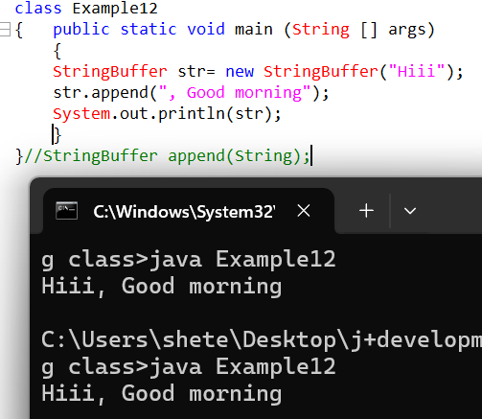

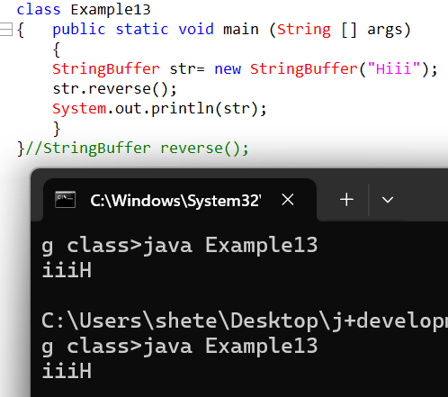

If we have to compare the content of both the Strings then what approach will you take.
We use equals method.
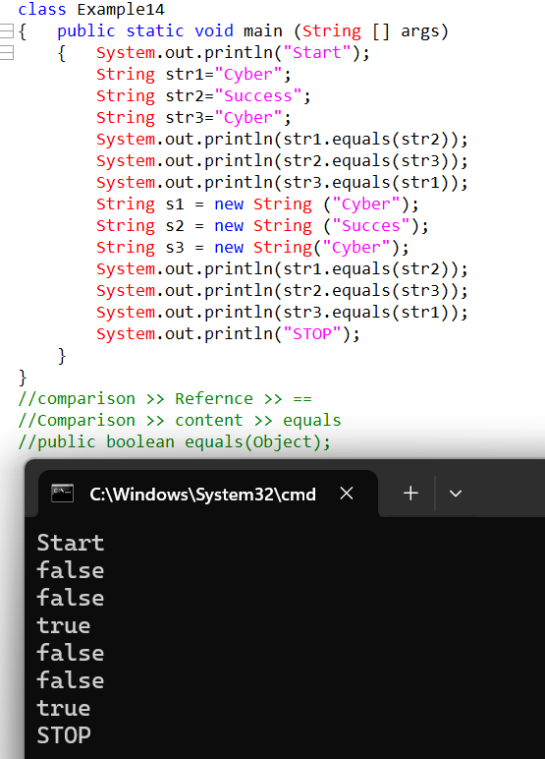
- == performs reference comparison
- Equals() performs content comparison
- Equals() in string buffer doesn’t perform content comparison but perform reference comparison
Write difference between == operator and equals()
- The == operator will always perform reference comparison.
- Whereas equals method performs both reference comparison as well as content comparison.
When does it perform reference comparison as well as content comparison
- If the equals method is called from string class it will perform content comparison.
- But if the same equals() is called from the string buffer class it will perform reference comparison.
Reason:
Equals() always perform reference comparison but in String class
Equals() is overridden which was inherited from object class.
in String Buffer equals() is not overridden that’s why it performs reference comparison.
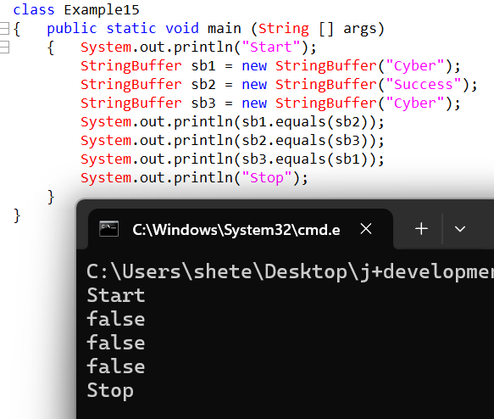

Interview Question
How do we convert string to string buffer and string buffer to string.
1.String to string Buffer
To convert string to string Buffer we can use constructor based approach.

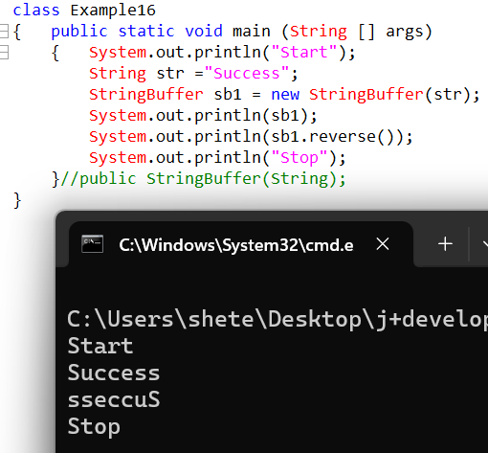

2.String buffer to String
There are two approaches to convert String buffer to String
1.Constructor based approach
2. toString()

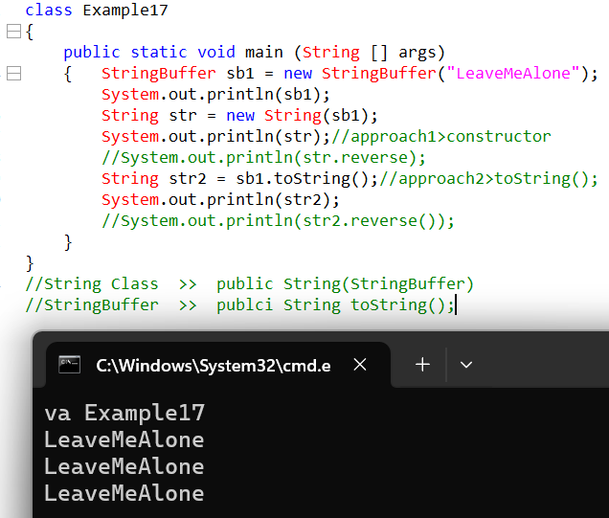

charAt()
The charAt() will accept an index arguments and will return the specified character at the respective position.
If the index is not present it will generate an exception. (Error)
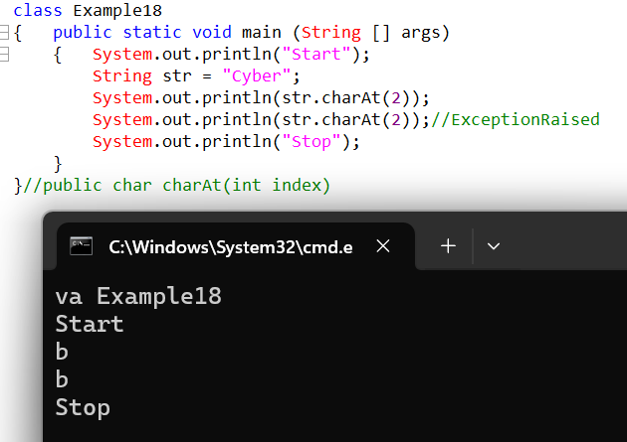

Contains();
public Boolean contains(CharSequence s);
The contains method will check if a character sequence is present within the String, if the character sequence is present, it will return true else it will return false.
isEmpty()
public Boolean isEmpty();
The is empty method will check if the String is empty or not, if it is empty it will return true else it will return as false.
startsWith()
public Boolean startsWith(String prefix)
The startsWith method will also check whether the starting sequence of the String is matching or not, if matching will return true else return false.
endsWith(String suffix);
public Boolean endsWith(String suffix)
The endsWith method will check character sequence at the end of sequence, if the character sequence is matching or not, if matching will return true else return false.
//example19

IndexOf()
Public int indexOf(String str)
The indexOf method will return the index of the first occurrence of respective character (String format), if the respective letter or String is not present it will return -1.
lastIndesOf()
public int lastIndexOf()
The lastIndexOf method will accept the character in string format and will return an int index of the last occurrence of respective character(String format), if the respective letter of String is not present it will return -1.
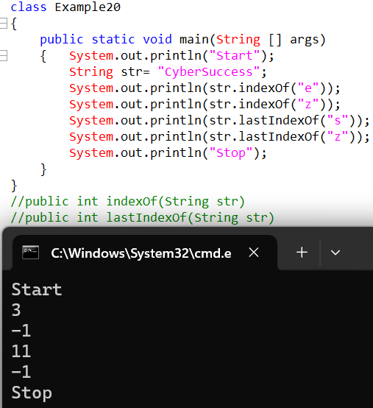
//String in built method are frequently asked in interviews.

SubString
A subString can be defined as an extraction of part of string, itself is called as SubString.
1.Public string subString(int beginIndex)
The substring method will accept the begin index, from that index onwards it will start extracting in the end of the string, if the begin index is not present it will raise an exception.
2.Public string subString(int beginIndex, int endIndex)
The substring method will start extracting from begin index and will keep on extracting till end index -1
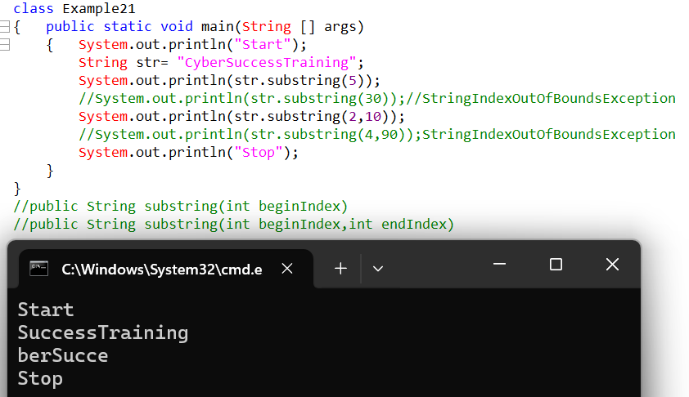
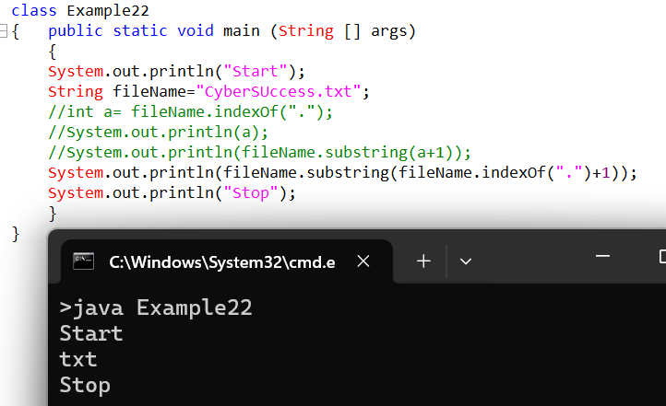
Public string toUpperCase()
Public string toLowerCase()
The toUppercase and toLowercase method are used convert the string either to the uppercase or in the lowercase.
Public String trim()
The trim method is responsible to trim the spaces on either sides of the strings the trim method cannot trim the spaces between the strings.
..example23
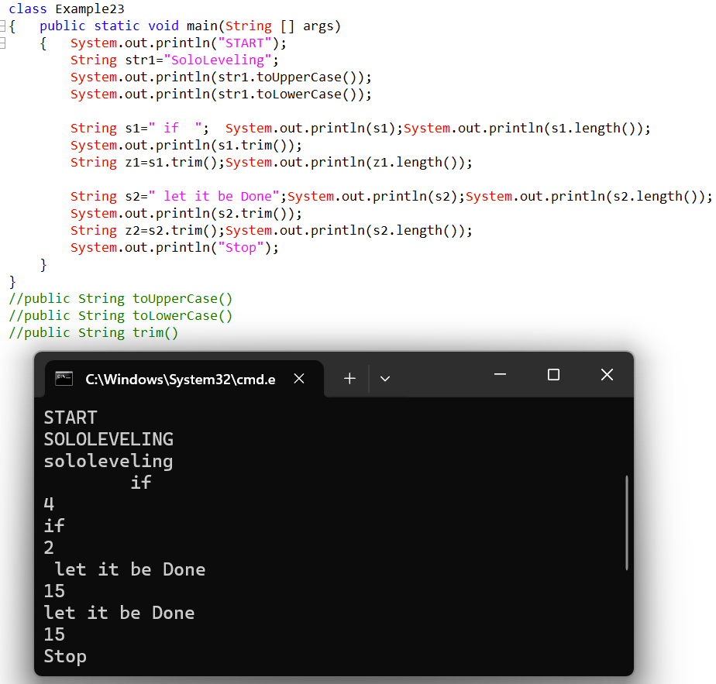
Public String[] split(String regex)
It returns array
If we want to store multiple values then we need to go for an array, whenever we store multiple values in array the index will always start from zero.
Type[]name = {};
Int [] a={};
- To get a size of an array we need to use length
- Length in an array is treated as a variable.
- Whenever we get length of an array, the length of array will always start from 1.
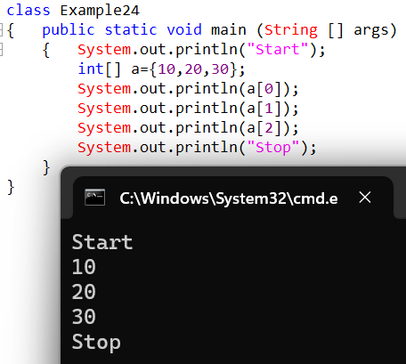
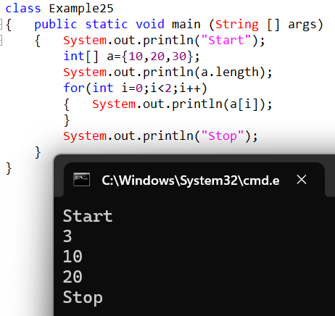
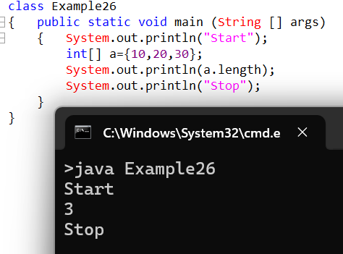

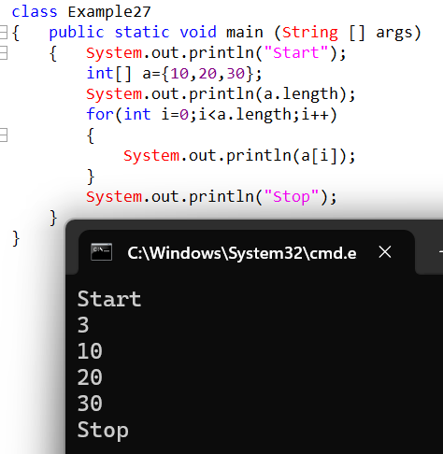

Str.split();
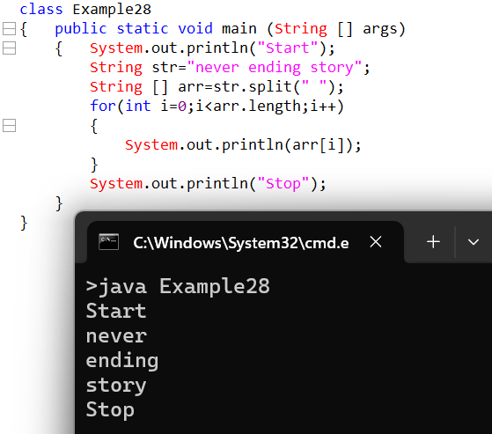

compareTo
//public int compareTo(java.lang.Object);
The way compare to method works it will compare both the strings the way compared to works is if the both strings are exactly same it will then return zero. If both the strings are not same it will return either + or – integer
When will it return + or –
1.Less than
If the first String first letter Unicode value is less than second String first letter Unicode value it will return a negative or –value.
2.Greater than
If the first string first letter Unicode value is greater than second string first letter Unicode value it will return a positive or + value.
What is difference between equalsIgnoreCase() and equals().
Equals() perform case sensitive comparison where as equalsIgnoreCase() performs case insensitive comparison.
What is difference between compareToIgnoreCase() and compareTo().
compareTo() perform case sensitive comparison where as compareToIgnoreCase() performs case insensitive comparison.
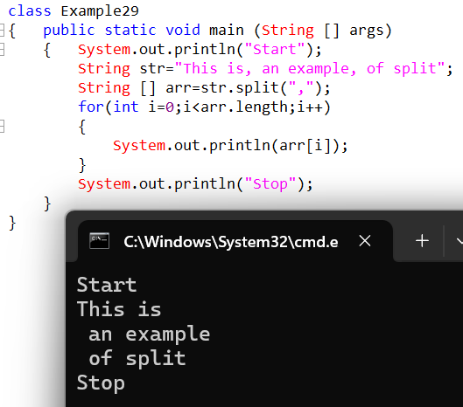
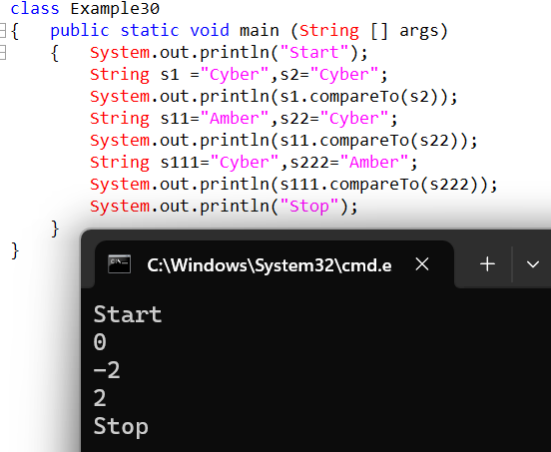

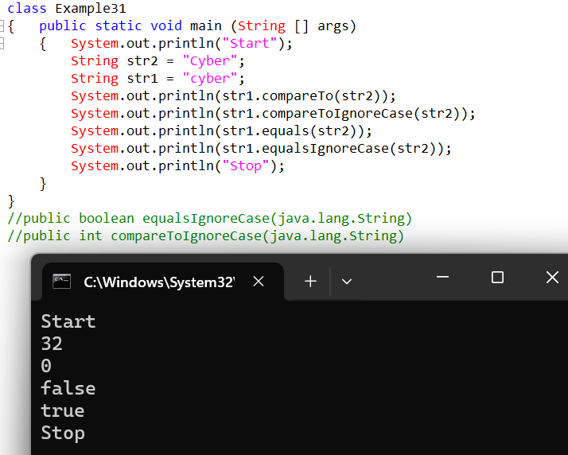

3.String Builder
- String builder class is part of java.lang package.
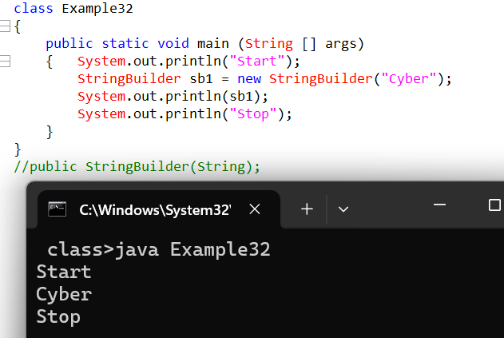
- The string builder class does not allow to create an object without new keyword it allows to create an object with new keyword.
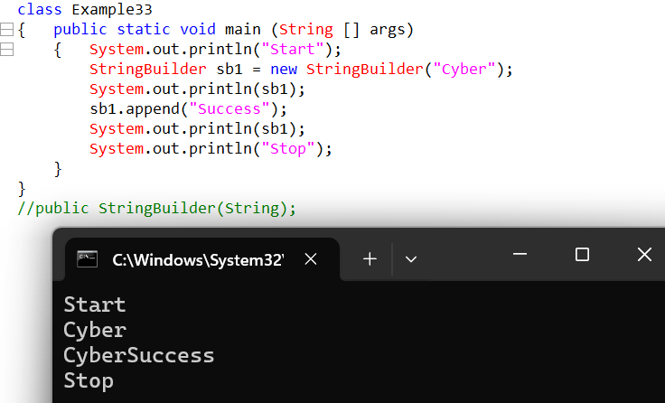
- String builder by nature is mutable class.
- The string buffer class and string builder class by nature are almost same However string buffer methods are synchronized where as string builder methods are non synchronized.
What do you mean by synchronized and non-synchronized?
If a method is synchronized a single thread is able to access a single method, transactions are safe but performance is little lower.
If the method is non-synchronized multiple threads are able to access single method transactions are not safe but performance is better.

4.String Tokenizer
- The purpose of string tokenizer is to split the string
- String tokenizer is part of java.util package.
- String tokenizer by default will split the string based on spaces.
- Whenever String Tokenizer object gets created it will by default split the string with respect to spaces.
- To extract the split String we have to perform two actions
1.Check if the element is present or not.
2.If the element is present then extract the element.
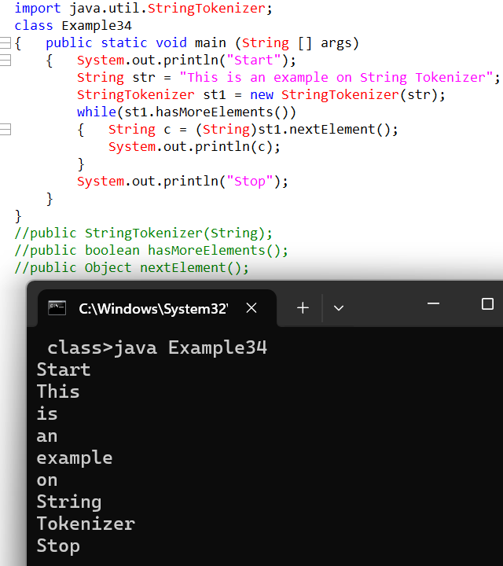

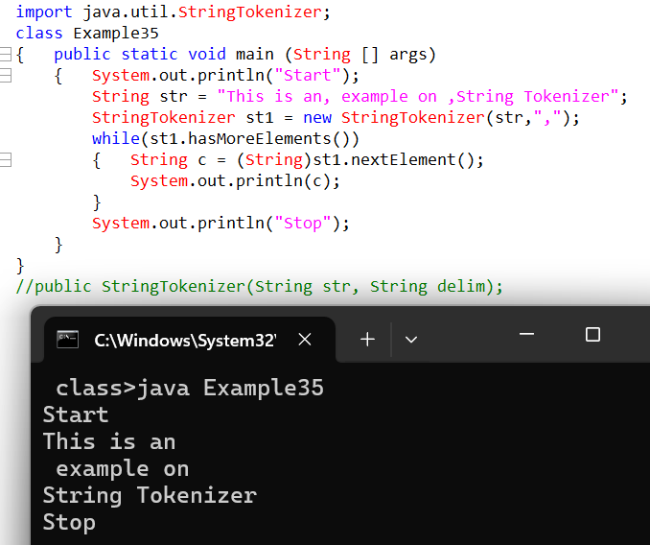Split method and string tokenizer both will perform the same operation but we will prefer to go for split method as string tokenizer is a legacy class and comes with number of limitations.
If I want to split the string I can directly use that object

IMP
What is String?
A string can be defined as sequence of characters or numbers or special characters within the pair of double quotes is called as String.

How many ways are there to create String object?
- With new keyword
- Without new keyword

What type of memory do they consume?
When we create a String object without using new keyword, it uses the String Constant Pool inside heap memory. It checks whether the same String object is already present or not. If present, it returns the same reference. If not present, it creates a new object in the String Constant Pool.
When we create a String object using new keyword, a new String object is created in heap memory every time, even if the same value is already present in the String Constant Pool. It creates a separate object and returns a new reference.

The == operator will perform what comparison
A. Reference comparison
B. Content comparison
It will perform reference comparison in the String class.

Whenever we print a normal class reference variable it will print the address but whenever we print string class reference variable it doesn’t print the address but it prints the value, Why?
• Whenever we print the reference variable of normal class it will internally call the toString() of the object class, the toString() of the object class will always be responsible to print the address.
• But within the string class the toString() method is overridden hence rather than returning the address it returns the value.

How can we calculate size of string?
length()

What type of comparison does equls() perform in String class?
Content comparison

Write difference between == operator and equals()
• The == operator will always perform reference comparison.
• Whereas equals method performs both reference comparison as well as content comparison.
When does it perform reference comparison as well as content comparison
• If the equals method is called from string class it will perform content comparison.
• But if the same equals() is called from the string buffer class it will perform reference comparison.
Reason:
Equals() always perform reference comparison but in String class
Equals() is overridden which was inherited from object class.
in String Buffer equals() is not overridden that’s why it performs reference comparison.

How do we convert string to string buffer and string buffer to string.
1. String to string Buffer
To convert string to string Buffer we can use constructor based approach.
2. String buffer to String
There are two approaches to convert String buffer to String
- Constructor based approach
- toString()

charAt()
The charAt() will accept an index arguments and will return the specified character at the respective position.

compareTo()
//public int compareTo(java.lang.Object);
The way compare to method works it will compare both the strings the way compared to works is if the both strings are exactly same it will then return zero. If both the strings are not same it will return either + or – integer.
When will it return + or –
1. Less than
If the first String first letter Unicode value is less than second String first letter Unicode value it will return a negative or – value.
2. Greater than
If the first string first letter Unicode value is greater than second string first letter Unicode value it will return a positive or + value.

What is difference between equalsIgnoreCase() and equals().
Equals() perform case sensitive comparison where as equalsIgnoreCase() performs case insensitive comparison.

What is difference between compareToIgnoreCase() and compareTo().
compareTo() perform case sensitive comparison where as compareToIgnoreCase() performs case insensitive comparison.

Difference between String, StringBuffer and StringBuilder
Feature | String | StringBuffer | StringBuilder
Mutability | Immutable | Mutable | Mutable
Memory Change | New object created on modification | Same object modified | Same object modified
Thread Safe | Yes (immutable nature) | Yes (synchronized) | No
Performance | Slow if frequent changes | Medium | Fastest
Synchronization | Not required | Yes | No
Content Comparison | equals() compares content | Use toString().equals() | Use toString().equals()
Storage | SCP / Heap | Heap | Heap
Best Use | Fixed text | Multithreaded mutable text | Single-threaded mutable text
Introduced In | Java 1.0 | Java 1.0 | Java 1.5
Methods | concat(), substring() | append(), insert(), reverse() | append(), insert(), reverse()

Quick Memory Trick:
String → Immutable
StringBuffer → Mutable + Thread Safe(Synchronized)
StringBuilder → Mutable + Fastest (Asynchronized)

What do you mean by synchronized and non-synchronized?
If a method is synchronized a single thread is able to access a single method, transactions are safe but performance is little lower.
If the method is non-synchronized multiple threads are able to access single method transactions are not safe but performance is better.

